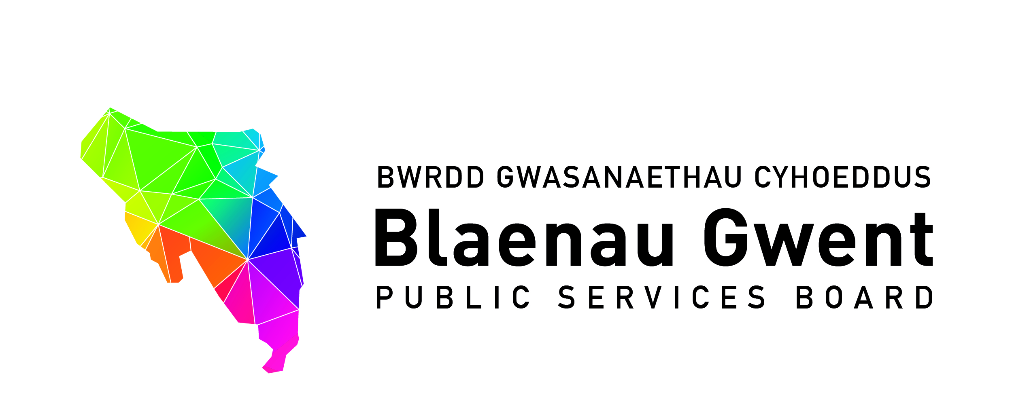

Blaenau Gwent Public Services Board Meeting

To be held: Monday, 14 October 2019 (2.00 p.m. – 4.00 p.m.)

Venue: Seminar Room, Ysbyty Aneurin Bevan, Ebbw Vale, NP23 6GL
http://www.wales.nhs.uk/sitesplus/866/page/41413#Location

1. Welcome and Apologies (Chair)

2. Notes of Previous Meeting (Chair) (papers attached) (10 Mins)

a) PSB Meeting Notes – 1st July 2019 for accuracy (Chair)
b) Action Sheet – 1st July 2019 (BE)

3. Annual Progress Report (BE) (5 mins)

http://www.blaenaugwentpsb.org.uk/news/annualreport2019.aspx

PART 1 – DISCUSSION SPACE (1 hr)

4. Well-being Plan Delivery Plan – Year 2 PSB Review

For action\decision

- Reviews of Current PSB Well-being Programme (supporting papers)

- Early Years First 1000 days programme (Aneurin Bevan/PHW)
- Adverse Childhood Experiences (Gwent Police)
- Maximising opportunities for prosperity (BGCBC)
- Blaenau Gwent On the Move (BGCBC)
- Working Together on Universal Credit (Tai Calon)
- Blaenau Gwent Community Safety Hub (Gwent Police)
- Age Friendly Communities (BGCBC)

For action\decision

- Emerging Projects for 2019/20 (supporting papers attached)
- Building Healthier Gwent & Integrated Well-being Networks (SA/EP)
- Climate Change (MM)
- Tackling Food Poverty in Blaenau Gwent (JL)
- Foundation Economy (MM)

For information

- Regional Funded Projects for PSBs from Welsh Government 19/20 (update paper attached) (BE)

i. Gwent Futures – Community Risk Register
ii. Collaborating on Improving Access to Data
iii. Reporting on key messages – Annual Reporting

- Gwent Travel Charter – request for information public sector bases in Blaenau Gwent

PART 2 - PARTNERSHIP BUSINESS (30 mins)

5. PSB Scrutiny Committee Work Programme 2019/20 (BE)

For consideration and action

(a) 6 January 2020 Items
(b) April 2020 Items

For information

(c) Reporting timeframe requirements for PSB Scrutiny Papers

6. Wales Audit Office Review of PSBs (attached)

7. Items from partners for next meeting

8. Any Other Business (Chair)

9. Items for information

- PSB Strategic Support Group Notes – 15 August 2019 (paper attached)
- PSB Strategic Support group notes – 25th September 2019 (draft notes attached)
- GSWAG Notes - Dates

10. Date of Next Meeting

Monday, 20th January, 2020 at 2.00 pm until 4.00 pm - Venue to be determined

