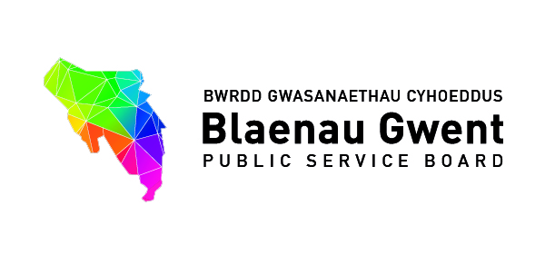

Blaenau Gwent Public Service Board

To be held: Monday 24th July 2017 (2.00pm – 4.00pm)
Venue: General Offices, Steelworks Road, Ebbw Vale, NP23 6AA

1. Welcome, introductions and apologies Chair [10 mins]

- Welcome to representation from Office of Future Generations Commissioner who have been invited to join the meeting.

For action\decision

- Reconfirmation of Chair (as per requirements of the Well-being of Future Generations
Act following local government elections);
- Confirmation of Vice Chair
- Changes of representation on Board from partner organisations:
- Gwent Police - Julian Williams for Jeff Farrar
- Public Health Wales – Dr Sarah Aitken for Dr Gill Richardson
- Aneurin Bevan University Health Board – Phil Robson for David Jenkins
- Verbal update on appointment of Managing Director for Blaenau Gwent Council (Chair)

2. Notes of previous meeting [5 mins] (papers attached)

a) 24th April Special PSB meeting for accuracy (Chair)
b) Summary Action Sheet (Bernadette Elias)

3. Next steps for Blaenau Gwent Well-being Planning –round table discussion

For information and context (Stephen Gillingham) [15 mins]
a) ‘Indicative priorities for setting draft local well-being objectives’ agreed by PSB in June 2017 (document attached)

b) PSB Stakeholder Event to further develop the indicative priority areas
held on 13 July
i) Overview of the Event
ii) Short video from member of Blaenau Gwent School Grand Council

(supporting papers and presentation from the event attached for information)

3. (Continued)

Discussion Points:

c) What analysis or further research would help support the PSB to be able to set their ‘collective’ well-being objectives? [45 mins]

Using the indicative priority of Adverse Childhood Experiences [ACES] as an example. Members will see the feedback from the participants at the event, and are to consider how they would like the next stage of analysis is to be approached e.g. understanding percentage of existing interventions identified which focus on preventative vs reactive approaches .

(Letter from Alyson Francis, Director, ACE Support Hub, Cymru Well Wales attached for information)

d) Identifying the links between partner organisation Well-being Objectives and the evolving PSB indicative priorities [15 mins]
(Copies of well-being objectives of statutory partners attached)
4. Partnership Business [30 mins]
For action\decision
a) Recommendations to the PSB for consideration from the PSB Strategic Support Group being held on 19 July (Bernadette Elias) (papers attached)

- ESF Developing Vulnerability Intelligence Regional Project – Recommendation for PSB to further scope project via the Gwent Strategic Needs Assessment Group
- Legacy Funding – SSG recommends PSB to support Option 1

b) VAWDASV (Violence Against Women, Domestic Abuse and Sexual Violence) (Rebecca Haycock) (papers attached)

i) Governance proposal paper for PSBs
ii) Domestic Homicide PSB Review

5. Any other Business Chair [5 mins]
6. Items for information (papers attached)
a) PSB Spring Bulletin 2017
b) Legacy Funding – progress update report on Communities First
c) Progress report - funding to support PSBs 2017/18
d) Welsh Government Regional Fund Grant – Overview of Happy Cities, Futurology Projects and Progress Report
f) Response letter to Office of Future Generations Commissioner
g) Public Health Wales - Launch of the WBFG Act Projections Tool
Local Authority (English) Local Authority (Welsh)
Health Board (English) Health Board (Welsh)
7. Date of next meetings:
- Consider Schedule of Meeting moving forward (Chair)
- Request for meeting with Representation from Office of the Future Generations Commissioner (FGA Officer)

Current PSB Meeting Schedule

Date | Venue | Time
24th July 2017 | Civic Centre, Executive Room | 2.00pm to 4.00pm
10th October 2017 | Civic Centre, Executive Room | 2.00pm to 4.00pm
16th January 2018 | Civic Centre, Executive Room | 2.00pm to 4.00pm
13th March 2018 | Civic Centre, Executive Room | 2.00pm to 4.00pm

