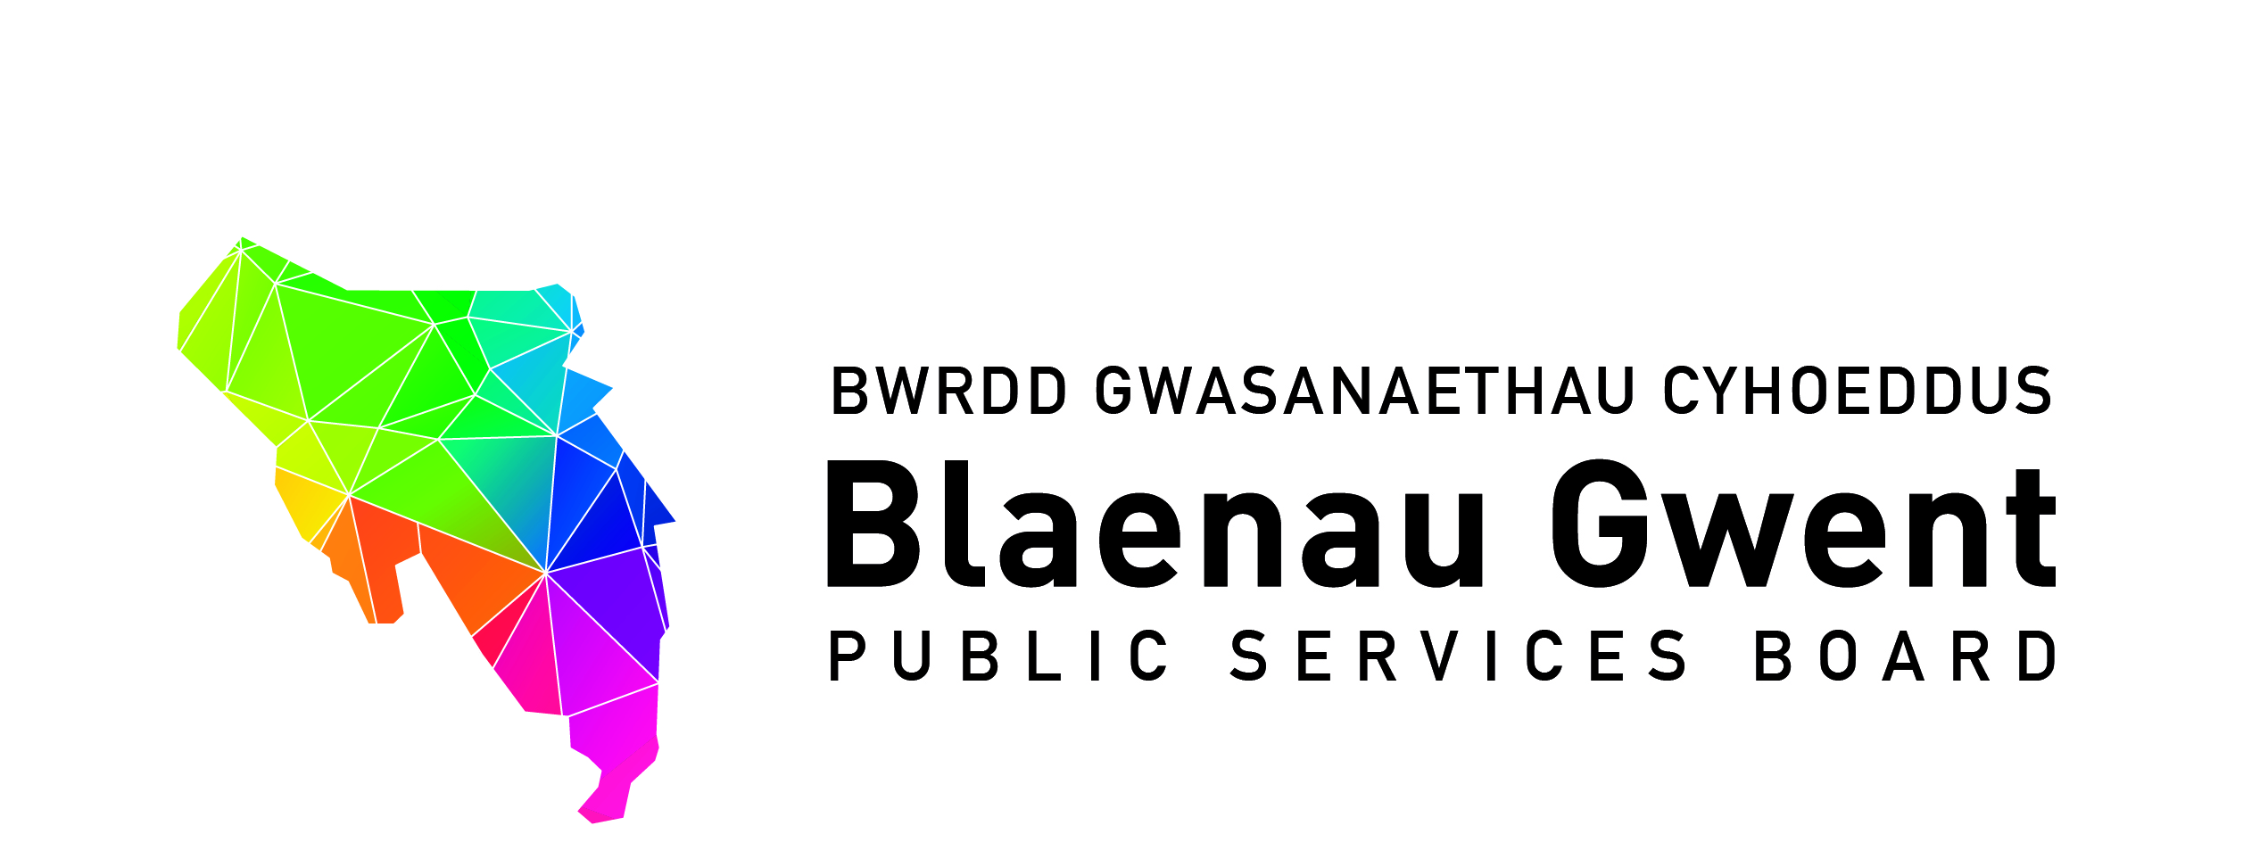

Blaenau Gwent Public Services Board Special Meeting

To be held: Monday, 1st July 2019 (2.00 p.m. – 3.30 p.m.)

Venue: Executive Room, Civic Centre, Ebbw Vale, Gwent. NP23 6XB

1. Apologies (Chair)

2. Notes of Previous Meeting (Chair) (papers attached) (10 Mins)

(a) PSB Meeting Notes – 28th January 2019 for accuracy
(b) Action Sheet – 28th January 2019
(c) Recommendations from PSB Strategic Support Group
(i) Early years Integration Transformation Programme (BE)

PART 1 – DISCUSSION SPACE

3. Annual Progress Report and Launch (1 hour)

- Annual Progress Report

Facilitated session to review the key elements of the Annual Progress Report.

- PSB Annual Report Launch & Maximising Opportunities for Prosperity Event with Stakeholders – 15th July 2019

An outline of the Event and updated position.

PART 2 - PARTNERSHIP BUSINESS

4. Partnership Business (15 mins)

For action\decision

- PSB Partnership Structure (information attached) (MF)

To endorse the Partnership Structure.

- Age Friendly Communities (Paper attached) (BE)

For information

- Blaenau Gwent On The Move (Paper attached for information) (BE)

Proposal to provide a presentation on the project to a future PSB Meeting.

- Academi Wales PSB Board Development (information attached) (PS)

Item for October PSB Meeting.

5. Key Information from Regional Working Partnerships and Groups

For information

- The Notes of the GSWAG Meeting to be circulated following sign off on the 4th July, 2019.

6. PSB Dates for 2019/ 2020 Diary (information attached) (Chair)

Schedule of dates for 2019/2020 for consideration.

7. Any Other Business (Chair)

8. Items for information

- PSB Strategic Support Group Notes – 12th April, 2019 (paper attached)
- PSB Strategic Support Group Notes – 24th May, 2019 (paper attached)

9. Date of Next Meeting

Request for partners to offer venues to host the next meeting scheduled to be held on Monday, 14th October, 2019 at 2.00 p.m.

