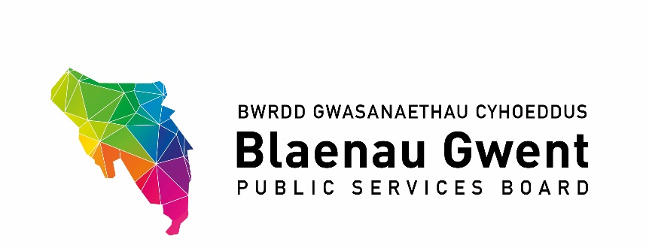

Blaenau Gwent Public Services Board Meeting

Date: Monday, 21st September, 2020

Venue: Virtually via Microsoft Teams

1. Welcome and Apologies

In Attendance -

Nigel Daniels (Chair) | Blaenau Gwent County Borough Council
Emrys Elias (Vice-Chair) | Aneurin Bevan University Health Board
Michelle Morris | Blaenau Gwent County Borough Council
Bernadette Elias | Blaenau Gwent County Borough Council
Dewi Jones | South Wales Fire & Rescue
Amanda Thomas | Gwent Police
David Arnold | Blaenau Gwent County Borough Council
Councillor Martin Cook | Blaenau Gwent County Borough Council
Andrew Parker | Blaenau Gwent County Borough Council
Guy Lacey | Coleg Gwent
Glyn Jones | Aneurin Bevan University Health Board
Howard Toplis | Tai Calon
Jon Goldsworthy | Natural Resources Wales
Paul Symes | Blaenau Gwent County Borough Council
Amanda Lewis | Gwent Probation
Stephen Tiley | GAVO

Apologies -

Mark Hobrough | Gwent Police
Dean Medcraft | Welsh Government
Huw Jakeway | South Wales Fire Authority
Johanna Robinson | Gwent Police and Crime Commission
Rhydian Ayres | Welsh Government
Carl Williams | Gwent Police
Richard Pryce | Aneurin Bevan University Health Board

1. Welcome & apologies

The Chair welcomed everyone to the meeting and noted the apologies accordingly.

2. Notes of Previous Meeting

- PSB Meeting Notes – 20th January, 2020

The notes were agreed as a true record of proceedings.

- Action Sheet – 20th January, 2020

ACES Closure Report – it was agreed that this would remain on the action sheet.

Funding OPC – It was reported that the deficit for this financial year would be covered by the Council’s budget. An impact report would be required as the deficit would be in the 2022/2023 budget and the funding covers a key role in the Council.

ACTION: OPC to bring an impact report to the next meeting of the PSB.

3. Recommendations from Other Groups

- SSG

PSB Annual Report

BE advised that the SSG had agreed that the Annual Report be recommended for approval to the PSB. BE commend the work undertaken by DA and PS on behalf of the Chair of the PSB to complete the Annual Report.

Participatory Budget

The SSG asked for clarity to be sought to ascertain if funding could be transferred to the next financial year. It would be difficult in the current climate to engage with residents and therefore the support of the PSB was required to take the approach of extending the deadline for the next financial year.??

(b) Regional Groups

G10 Regional PSB Paper

It was reported that there had been further discussions with partners and leaders around a Regional PSB. It was felt that there were strong partnerships and working arrangements in place which would be beneficial to working regionally. The Chair concurred that there was a robust enthusiasm to take this forward and other Leaders welcomed making a regional PSB a reality

GSWAG
Gwent Travel Charter

It was reported that the Gwent Travel Charter was due to be considered at the next G10 meeting and work would commence once the proposal had been agreed. BE added that it was hoped that work would commence in November, however due to current climate consideration had to be given on how to engage with organisations.

This was the first stage of proceedings and there would be an opportunity for organisations to get involved.

ACTION: Report from the G10 to be presented to a future meeting of the PSB.

PART 1 – DISCUSSION SPACE

4. PSB Strategic Work Programme 2020/21 Position Statements

The respective PSB Sponsors and DA provided an update on the work programmes as outlined in the reports and the main points were brought out, as follows:-

- Blaenau Gwent Sustainable Food Programme - ideas from PSB members on how best to utilise this capital funding are welcome.

- Climate Change – Mitigation – nominations for a working group to be held in October were sought.

- Climate Change – Adaption – this project had been on standstill since March due to the COVID-19 conditions and associated guidance on engagement.

ACTION: The working group attempt to meet before Christmas to see what could be taken forward.

- Integrated Well-being Network – due to the COVID-19 the framework for IWN have been revised to support the recovery response to the pandemic and integrated work with the Test, Trace and Protect service.

- First 1,000 Days

ACTION: A progress report would be presented to the next PSB to report the delay in the project and how it would be addressed.

- Age-Friendly Communities – a Sponsor needed to be appointed to this programme going forward.

ACTION: A progress report to be presented to the next meeting.

- Community Safety Hub

- Foundational Economy

The Chair thanked everyone for their updates and advised that since 2017 he had been proud of the levels of engagement undertaken in Blaenau Gwent which had been politically driven. He noted that a number of the programmes had been delayed due to the need for engagement with the public and therefore suggested that the PSB work together in an attempt to see how engagement could be recommenced safely as it would greatly benefit our communities.

5. NRW Strategic Allocated Funding for PSBs

It was reported that an allocation of Natural Resources Wales grant funding was available to support delivery of the well-being objectives of the Public Services Boards across Wales.

An expression of interest needed to be submitted by end of September with applications to be returned by end of March. Due to the limited timescale a local project would need to be pursued and it was hoped that options could be provided virtually to partners in October for consideration.

6. PSB Annual Report 2019/20

BE noted the Annual Report which was a comprehensive document which highlighted all the work undertaken by the PSB. BE reported that unfortunately the Authority had been unable to utilise the funding from Welsh Government to include videos due to the current restrictions association with COVID-19. Therefore, the funding received needed to be returned to Welsh Government. However, given the challenges faced with the pandemic the report was very comprehensive and gave an excellent overview of the work of the PSB.

PART 2 – PARTNERSHIP BUSINESS

7. BGCBC Covid-19 Recovery Themes – Update on Current Position

MM outlined the report which presented the indicators to assist the community & economy being back up and running, as safely as possible in the new state of normality whilst living with COVID-19. MM advised that the document was developed by Gwent Recovery Group and provided indicators of the traffic light nature to assist with the impact within communities. These indicators would be used to supplement the work to be undertaken in Blaenau Gwent.

MM referred to the current situation in terms of cases across Gwent and the wider area. She advised that in light of recent lockdowns and the escalation of cases in Blaenau Gwent the Authority was very much back in response mode and stated that the report had been drafted previously when focus had been on recovery.

8. Agenda Items for Next Meeting from Partners

The Vice-Chair asked that any items for the next meeting be forwarded to officers at the Council.

9. Items for Information

The following items for information were considered:-

- Written Communications with WG Minister for Local Government & Housing
- Welsh Government Strategic Review of Partnerships
- Future Generations Commissioner’s Annual Report 2019/20

10. Any Other Business

There were no other items of business were raised.

11. Dates for the Next Partnership Meetings

The Vice-Chair advised that the next planned meeting was scheduled on Monday,
30th November, 2020, however it was proposed that it be rescheduled to Monday,
14th December, 2020.

There were no objections to the change in date.

