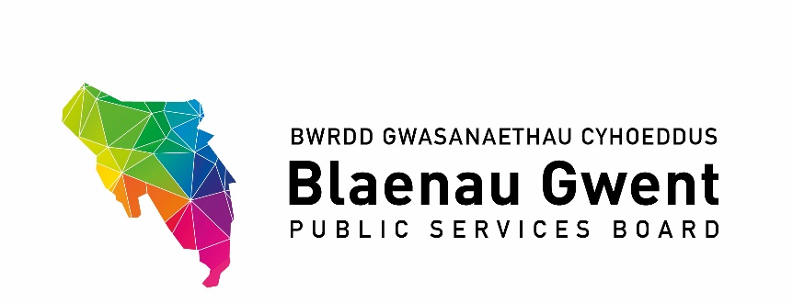

Blaenau Gwent Public Services Board

To be held: Monday 30 November 2020, 9:30 – 11:30am
Venue: Microsoft Teams meeting
Chair: Cllr Nigel Daniels

Agenda

- Welcome & apologies (Chair)

- Notes of Previous Meeting (Chair)
a) PSB Meeting Notes – 21 September for accuracy (Chair)
b) PSB Action Sheet – 21 September (BE)

- Recommendations from other groups
- SSG, 12 November 2020 (BE)
- Draft minutes for information (paper attached)
- Gwent Travel Charter (paper attached)
- Participatory Budgeting (paper attached)
- Regional Groups:-
- GSWAG (AP)

PART 1 – DISCUSSION SPACE

- PSB Strategic Work Programme 2020/21
- Blaenau Gwent Sustainable Food Programme (HT) (paper attached)
- Age-Friendly Communities (ST) (paper attached)
- Climate Change – Mitigation (MM) (paper attached)
- Climate Change – Adaptation (JG)
- Integrated Well-being Networks (SA)
- First 1,000 Days (GJ)
- Foundational Economy (GL)

PART 2 – PARTNERSHIP BUSINESS

- Funding Opportunities
- NRW Strategic Allocated Funding for PSBs (JG) (paper attached)
- Tai Calon Brighter Futures Fund (HT) (paper attached)

- PSB Scrutiny Committee Forward Work Programme (BE) (paper attached)

- Agenda Items for Discussion Space and Next Meeting from Partners

- Items for Information
- Blaenau Gwent Employment & Skills Plan (paper attached)
- ABUHB Gwent Mental Well-being Foundation Tier (paper attached)
- BG PSB Response to the Public Accounts Committee Inquiry into the Barriers to the successful Implementation of the Well-Being of Future Generations (Wales) Act 2015 (paper attached)
- Thriving Places Index: http://www.thrivingplaces.wales/Default?lang=en-GB

- Any Other Business

- Dates for the Next Partnership Meeting
- Monday 8 March 2021
- Monday 7 June 2021

