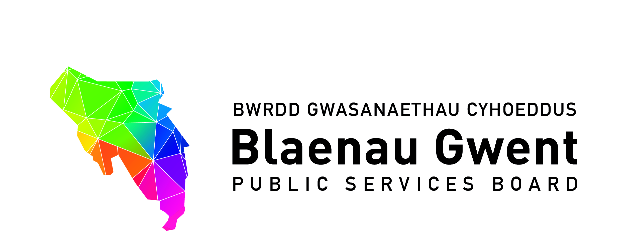

Blaenau Gwent Public Services Board

To be held: Monday 28th January (13.00pm – 4.00pm)

Venue: Council Chamber, Civic Centre, Ebbw Vale, Blaenau Gwent, NP23 6XB

Part I: GWENT FUTURES WORKSHOP – ASH FUTURES [2 hrs]

1. Welcome
Special Gwent Futures Workshop held with PSB and PSB SSG members; the Chair and Vice of PSB Scrutiny Committee, and Representation from the Youth Forum.

2. Session Overview (facilitated by Simon Hooton and Alistair Wilson, Ash Futures)
- Introduction
- Horizon scanning of future – Maximising Opportunities for Prosperity
- Workshops
- Summary and consideration of next steps/implications

Following the workshop Ash Futures encouraged attendees to continue the conversation which encourages long-term thinking; consideration of future trends research against key well-being priorities in order to inform Well-being Plan delivery.

SH confirmed that information from the session will be shared with attendees when available and the session was adjourned.

All non-PSB members left at this point

Part II: PSB PARTNERSHIP BUSINESS [1:45hrs]

1. Welcome & apologies (Chair) [5 mins]

Apologies (Chair)

In attendance:
Michelle Morris (Chair) | Blaenau Gwent County Borough Council
Diana Binding | National Probation Service Wales
Joe Logan | Tai Calon Community Housing
Johanna Robinson | Office of Police & Crime Commissioner
Emrys Elias | Anuerin Bevan University Health Board
Sarah Aitken | Public Health Wales
Bill Purvis | Natural Resources Wales
Nick McLain | Gwent Police
Mike Richards | Gwent Police
Dewi Jones | South Wales Fire & Rescue Service
Martin Featherstone | Gwent Association of Voluntary Organisations
Heather Nicholls | Wales Community Rehabilitation Company
Bernadette Elias | Blaenau Gwent County Borough Council (PSB Support)
Andrew Parker | Blaenau Gwent County Borough Council (PSB Support)
Emma Scherptong | Blaenau Gwent County Borough Council (PSB Support) (Notes)

Apologies:
Nigel Daniels | Blaenau Gwent County Borough Council
Huw Jakeway | South Wales Fire & Rescue Service
Guy Lacey | Coleg Gwent
Julian Williams | Gwent Police
Jeff Cuthbert | National Probation Service in Wales
Jon Goldsworthy | Natural Resources Wales
Rhodri Asby | Welsh Government
Glyn Jones | Aneurin Bevan University Health Board

The meeting was conducted with Quorum Status and apologies were noted.

MM welcomed everyone to the Board meeting and introductions were made

- PSB Vice Chairing Arrangements (Emrys Elias, Vice Chair of the ABUHB, replacing Phil Robson)

MM introduced Emrys Elias, Vice Chair of ABUHB and made the proposal that he continues the role of PSB Vice Chair as he predecessor did Phil Robson.

Members agreed for EE to assume the role of PSB Vice Chair.

2. Notes of previous meeting (Chair) [10 mins] (Papers attached)
a) PSB meeting 22 October 2018 notes for accuracy

Notes were agreed to be an accurate record.
b) Action Sheet from 22 October 2018

MM invited BE to summarise action updates.

All action points were agreed as completed.

c) Recommendations from PSB Strategic Support Group

BE outlined that under Agenda Item 4c) there had been a recommendation from SSG for PSB to consider the option for a discussion space item on the preparedness for Exiting the EU - including the strategic risk consideration.

BE informed members that the PSB Partnership Structure had also been considered at SSG and was being finalised.

MM asked BE whether the structure had already been agreed by PSB.

BE confirmed that it had.

MF suggested that the final PSB Partnership Structure is presented to PSB in April for ratification.

Action: PSB Partnership Structure to be presented to PSB in April for ratification.

3. Blaenau Gwent Well-being Delivery Plan Lead Updates (papers attached) [30 mins]
For action\decision

a) Best Start in Life - Early Action Together Programme [ACES] (NM)

MR gave an overview of the Home Office led Early Action Together Programme report and
highlighted key recommendations for the Boards consideration:

i) PSB members identify representatives to attend training;
ii) Rhian Bowen-Davies become a member of the PSB’s Strategic Support Group
iii) Early Action Together Programme Reports (e.g. Annual Report) is presented to PSB

MR outlined that a standalone Board governs the programme, and that Blaenau Gwent is
Represented and that Blaenau Gwent and Newport have been selected as pathfinder
areas.

The programme has four primary National Objectives which Members were asked to note
in Appendix 2. Implementation of the objectives includes the delivery of Level 1 ACE
Awareness Training for Police and wider partners.

MR confirmed that the programme is developing an ‘early help’ concept which looks to
strengthen the delivery of existing Early Years provision. The concept is to be presented to
the Early Action Together Programme Board on the 20th February, 2019 along with a six
month evaluation report.

MR also clarified that the Welsh Government ACEs Hub is separate to the programme and
is also delivering Level 1 training for practitioners.

MM said it would be useful to know the breakdown of the numbers of partners who had
received training. MR said this information could be provided.

MR informed members that since delivery of the training there has been an increase in the
number of ACE referrals, however a high percentage of these were ‘No Further Action’ as
they didn’t reach the safe guarding thresh hold. To improve the quality of referrals a Police
Officer is to be placed within the IAA Team (Information, Advice and Assistance) to
support screening.

SA said it will be important for the Board to consider how it organises support for families
who are currently below the thresh hold and how the programme is being evaluated.

MR said that this is being considered through Ebbw Fawr School, testing what the offer is
through the delivery of a Schools Liaison Programme overseen by a Task & Finish Group.
MR confirmed that evaluation is currently being dealt with by the Children’s Board which
sits under the Regional Partnership Board.

BE informed Members that this was considered as part of the Strategic Support Groups
discussion space about alignment of RPBs and PSBs and how delivery can be mapped
and tracked.

MR thanked support received by Lynnette Jones (Director of Education) and Tanya Evans
(BGCBC – Head of Children’s Services).

The Board agreed the recommendations of the report.

b) Safe and Friendly Communities - Community Safety Partnership Hubs (NM)

NM gave an overview of the report which formally asks the PSB to agree for the
community safety statutory functions to be discharged to the Community Safety
Partnership Hub, which were previously overseen by the Fair & Safe Partnership
Group, under the Single Integrated Plan arrangements.

NM highlighted that the hub will use a place based approach which is currently operating
inTorfaen and Caerphilly.

MM asked what the practical implications are.
NM confirmed that there will be a delivery group Chaired by a Superintendent and will
Area Based Locality approach.

AP said that discussions had already been held regarding setting up a core membership
for the group and that wider partners will be brought in to tackle problems as appropriate.

SA said as the Vice Chair of the Area Planning Board that it will be important to ensure the relationship with the Community Safety Sub-group is clear and set out within the Terms and Reference of the group. SA asked if further information can be provided on how local delivery mechanisms connect with regional partnerships (such as the Area Planning Board)

JR said currently the Safer Gwent Regional Partnership is seen as a practitioners group and questioned whether an Executive Board, such as the Criminal Justice Board fulfils this role which PSBs report to.

For awareness and decision
c) Getting Blaenau Gwent Active and Healthy – Verbal Update on BG on the Move (BE)

BE gave a verbal update on the progress of the project which includes wide stakeholder engagement and suggested a progress update report is presented at the April meeting.

ES added that whilst the funds to deliver the project is relatively small the project is effectively demonstrating implementation of the five ways of working.

Members agreed for a report to be presented in April.

Action: Getting Blaenau Gwent Active and Healthy – BG on the Move Project Report to be presented in April

For information
d) PSB Support Grant 2018/19, Well-being Events, 18 March – 22 March (BE)

BE informed the Board of a series of Well-being Events planned during March which are being developed based on findings from the Happy Communities analysis.

The Board noted the events.

e) International Women’s Day, 8 March (BE)

BE informed the Board that partners have been working together to organise an event to celebrate International Women’s Day which focuses on gender balance. BE said local key role models to support the day have been secured such as Chair of the Council, Mandy Moore, Youth Mayor and Deputy Youth Mayor and will also consider the Period Equity agenda.

4. Proposed Discussion Space Items for April PSB (Chair) [10 mins]
For action\decision
- Carbon Futures (deferred from previous PSB Agenda)
- Academi Wales attending PSB to facilitate Board Development Session (confirmed)
- Proposal for a special PSB session to share preparedness for Exiting the EU - including the strategic risk consideration

MM outlined the proposed options for discussion space items in April and asked the Board for comment.

The Board agreed for the April meeting to be split between the Academi Wales Board Development session and PSB Business.

Members suggested notes from the Gwent Futures workshop to be shared with Academi
Wales to scope opportunities for building on today’s discussions.

5. Partnership Business (Chair) [5 mins] (Attached)
For action/decision
a) Letter from Chair of 50+ Network (Councillor Mason) to PSB – Age Friendly Communities Programme

BE gave an overview of the letter and recommendations for the Board’s consideration.

The Board agreed for the Blaenau Gwent Strategy for Older People, Age Friendly
Communities Delivery Programme to be presented to the PSB in April.

6. Commissioning [5 mins] (papers attached)
For information
a) Support for PSBs 2019/20 (BE)
b) Healthy & Active Fund – Invitation to full application stage (EP)

7. Key Information from Regional Working Partnerships and Groups (BE) [5 mins]
For information
a) Ystadau Cymru - National Assets Working Group (Letter from Cabinet Secretary for
Finance attached)

8. Any Other Business (Chair) [5 mins]

9. Items for information (paper attached)
a) PSB Strategic Support Group Notes – December 2018

10. Date of next meeting
a) 29 April, 2019 – Venue to be agreed

Noted.

The Chair adjourned the meeting.

